INSTITUTE OF LATIN AMERICAN STUDIES NEWSLETTER

In this context, I strongly believe that cooperation in the academic field will deliver important benefits to both Latin America and the EU.

Inside This Issue
- Message from the Director
- MA in Latin American Studies
- Publication: `De Santiago a Bruselas pasando por Bucarest`
- The second Preparatory Seminar of the Second EU-LAC Academic Summit
- Opportunities

Volume 1 No.5 September 2014

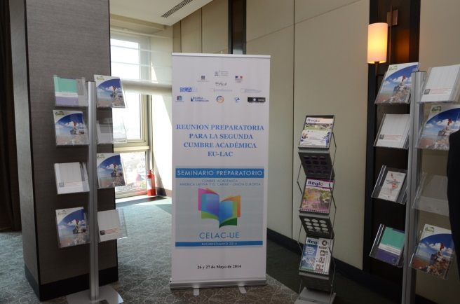

Message from the Director

Dear colleagues,

The cooperation between European Union and Latin America and Caribbean has made visible progress in the context of the new EU-CELAC dialogue stated in the Santiago Declaration. The European and Latin American leaders have expressed their commitment to work hard to further improve the privileged relations between the two regions.

In this context, I strongly believe that cooperation in the academic field will deliver important benefits to both Latin America and the EU.

I thank you for your support and your attention and I wish you success in your activities!

IORDAN GHEORGHE BĂRBULESCU

A new Master’s programme: Latin-American Studies

The Department Of International Relations and European Integration in Bucharest is opening in October 2014 its Master’s programme – Latin American Studies.

The MA Program in Latin American studies is an initiative of the Institute of Latin American Studies and of the Department of International Relations and European Integration within the National University of Political Studies and Public Administration and is the first of its kind in Romania.

The outlining of such a program resulted from the need to meet the requirements and changes occurring in the international system, as the Latin American states are becoming increasingly attractive for the international community.

Through its bilingual (English and Spanish) courses, the Program`s purpose is to introduce students to the developments in the Latin American space, to analyse phenomena triggering various actions and above all, to attempt to predict relations between the states in this area and the European Union, the US or other relevant actors in the international system.

The Program aims to become a regional point of interest for those intending to complete their training in international relations and to acquire expertise in Latin American issues.

More information on website http://dri.snspa.ro/masterate/studii-latino-americane/.

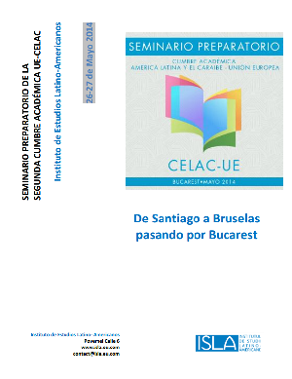
Publication: `De Santiago a Bruselas pasando por Bucarest`

The Institute of Latin American Studies has the honor to announce the appearance of the publication De Santiago a Bruselas pasando por Bucarest, incorporating the panels’ and workshops’ reports of the Preparatory Reunion for the second EU-LAC Academic Summit held in Bucharest between 26- 27 May 2014.

Thank you for your interest in the event and wish you pleasant reading!

`De Santiago a Bruselas pasando por Bucarest` publication can be accessed here:
http://www.isla.eu.com/wp-content/uploads/2014/08/De-Santiago-a-Bruselas-pasando-por-Bucarest.pdf

The second Preparatory Seminar of the Second EU-LAC Academic Summit

The Second Preparatory Seminar of the Second EU-LAC Academic Summit will be held at the Guadalajara University between 25-26 November 2014.
This seminar aims to progress toward achieving the goals of academic cooperation and integration stated in the Santiago Declaration, issued during the First Academic Summit in Chile, in January 2013. The event is open to all universities and academic institutions that express their interest and whose activities correspond to higher education, science, technology and innovation.

For further information please access: http://www.cucsh.udg.mx/actividades/segunda-cumbre-academica-union-europea-america-latina-y-el-caribe

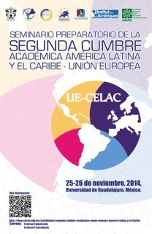

Source : http://www.cucsh.udg.mx/sites/default/files/images/2dac.jpg

Director of the Institute of Latin American Studies:  Iordan Gheorghe Bărbulescu  Editor-in-Chief:  Raluca Georgiana Săftescu  Editors:  Ioana Dodi, Adina Năstase, Laura Boșilcă,  Iulia Bălteanu, Silvia Iorgulescu, Mihai Ghigiu | In order to receive future issues of the ISLA Newsletter, you can subscribe accessing the following link: www.isla.eu.com  Institute of Latin American Studies  Povernei Street, no. 6, District 1, Bucharest, Romania  Tel.: 0372.177.146 / Fax: 021 318.08.91  E-mail: contact@isla.eu.com
Opportunities
ERANet-LAC: 1st Joint Call on Research and Innovation

In order to strengthen the bi-regional partnership in Science, Technology and Innovation, ERANet-LAC will implement two joint calls seeking to coordinate and cluster research programmes. Furthermore, the project will mutually open research infrastructures and coordinate and open innovation programmes.

ERANet-LAC will lay a special focus on the innovation dimension. It will seek to involve European and Latin American innovation agencies in the joint activities as well as in trust-building actions.
The joint activities carried out will be evaluated and function as a basis for a road map to be incorporated in a so-called EU-CELAC Platform for Funding Agencies. This funding platform will serve as information and communication platform and offer substantial guidelines as well as online working space to facilitate the development of future concrete bi-regional joint initiatives.

In the framework of the ERANet-LAC project, the 1st Joint Call on Research and Innovation of programme owners in the Member States of the European Union (MS), the Associated Countries to the 7th Framework Programme (AC), the Latin-American and the Caribbean Countries was launched on September 16th, 2014.

Deadline for submission will be 27th November 2014.
Deadline for submission of proposals including Brazilian partners: October 17th, 2014 (for further information see Brazilian Call Regulations).

More information: http://eranet-lac.eu/

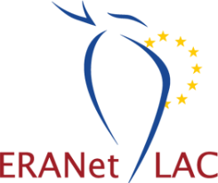

Invitation to Tender. Consultants and Experts for coordinating the I EU-LAC Youth Days: Education and Employment

The EU-LAC Foundation is inviting tenders for coordinating the first EU-LAC Youth days.
For further information, please click here: http://eulacfoundation.org/sites/eulacfoundation.org/files/TdR%20J%C3%B3venes.pdf

Deadline for applications: 15 October 2014.

